**CHAPTER 12: INDIVIDUAL BEHAVIOR**

**Perception:**

* Process through which people receive, organize, interpret information from environment
* People behave based of their perception
* People interpret things differently

**“Psychological contract”:**

* set of expectations held by an individual about what will be given and received in the employment relationship.
* It is fair enough: let employees contribute and be respected (have security from company)
* Balances contributions

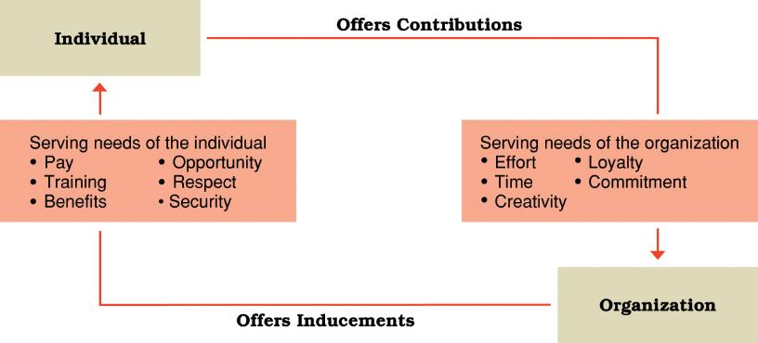

**Fundamental attribution error:** blame another’s performance failures at something internal (employee’s control) when it’s something external

**Ex:** It’s their fault! They are performing poorly.

**Attribution:** process of developing explanations for events

**Self-serving bias:** not blaming yourself when it is clearly yours. Blame on external factors instead of internal (opposite of FAE)

**Ex:** I work poorly, but it’s not my fault!

**Stereotype=** (1) you see somebody, (2) assign them to a broad group, (3) you assign attributes based upon group  
  
**Halo effect=** (1) you see somebody, (2) you focus on one attribute about them, (3) you assign other attributes based upon previous attribute  
(ex. I see a man/woman; they are a doctor; they must be smart, a good person, etc.

**Stereotypes:** Occur when someone is identified with a group or category, and then oversimplified attributes associated with the group or category are used to describe the individual.

**Ex:** He is British. He must like tea.

**Halo effects:** Occur when one attribute is used to develop an overall impression of a person or situation.

**Ex:** He likes tea. He must be British.

**Selective perception**: tendency to single out for attention those aspects of a situation or attributes of a person that reinforce or appear consistent with one’s existing beliefs, values, or needs.

How a person's expectations or the degree to which something stands out can affect observations.

**Projection**: projecting personal attributes to others (ex: I like projects, so I assume the other person does)

**Impression management:** systematic attempt to influence how others perceive us

* Dress properly to convey positive appeal
* Flatter others, give compliments to generate positive feelings
* Smile and eye contact
* Display high level of energy
* Project positivity

**Personality:** combination or overall profile of characteristics that makes one person unique to others

**Big 5 Personal traits**

* Extroversion (outgoing, sociable, assertive)
* Agreeableness (good-natured, cooperative, trusting)
* Conscientiousness (responsible, dependable, careful)
* Emotional stability (relaxed, secure, unworried)
* Openness (curious, receptive to new things, open to change)

**Personal traits that can affect work behavior:**

* **Locus on control:** they don’t believe in destiny, they have control of their lives
* **Authoritarianism:** whatever the boss says to do
* **Machiavellianism:** emotionally disconnected when they are using power, manipulative
* **Self-monitoring:** change and modify behavior in different situations and external factors
* **Type A personality:** impatience, always on pressure, perfectionism

Personalities are not necessarily fixed. Personality tests may help discover for yourself.

**Attitude:** someone’s behavior towards other people and things

**Components of Attitude:**

* **Cognitive:** This job is challenging
* **Affective/Emotional:** I don’t like this job
* **Behavioral:** I’m going to ask for a better job

**Cognitive dissonance:** Discomfort a person feels when attitudes and behaviors conflict. Many people alternate some of them.

**Ex:** Smokers know it is bad to smoke. Many of them later minimize or stop smoking overall

**Job satisfaction:** degree to which an individual likes/dislikes about their work

* Work itself
* Supervision
* Co-workers
* Advancement opportunities
* Pay, work conditions
* Security

**Stressors:**

* Things that cause stress
* From work, personal situations
* Potential to influence work attitudes, job performance and health

**Work factors as potential stressors:**

* Excessively high or low task demands
* Role conflicts
* Poor interpersonal relationships
* Too slow or too fast career progress
* Set up to fail
* Mistaken identity

**Constructive stress:**

* Positive influence
* Energizing and performance enhancing

**Destructive stress:**

* Negative influence
* Job burnout and workplace rage
* Bad attitude
* Poor self-esteem and health
* Lack of energy
* Lower performance and satisfaction